Pos/ Dashboard Login Process

1.POS Login Process
Overview: This module contain login process for the POS users with step by step There are three methods to log in to the POS system using valid credentials:
Login Methods
- Username & Password
- Passcode
- Swipe Card (Card integration must be enabled.)

1.1.Login Using Username & Password
Overview:The username & password is a method of login in POS System Using the valid credentials.

Path: Open POS>>Login >>
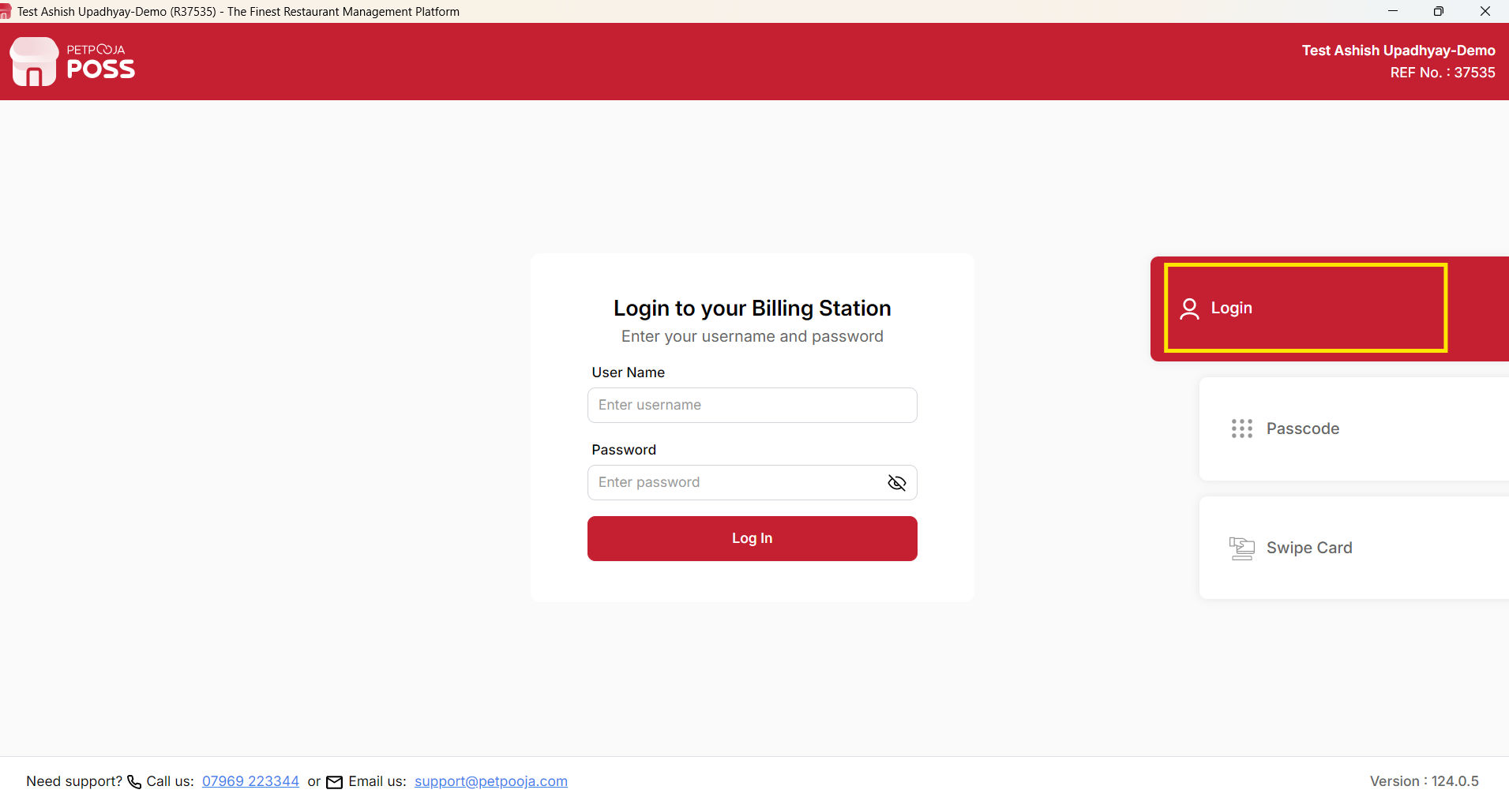
{Image Name: POS Login Screen Via Username & Password,
Description: The highlighted section indicates the POS Login screen, where users can log in using their assigned Username and Password. Enter the valid login credentials and click Login to access the POS system. This is Step 1 to login using Username and Password. }

1.2 Login Using Passcode
Overview:The Passcode is a method of login in a POS System in a very quick way using 4 digits of Passcode.

Path: Open POS>>Login >>Passcode

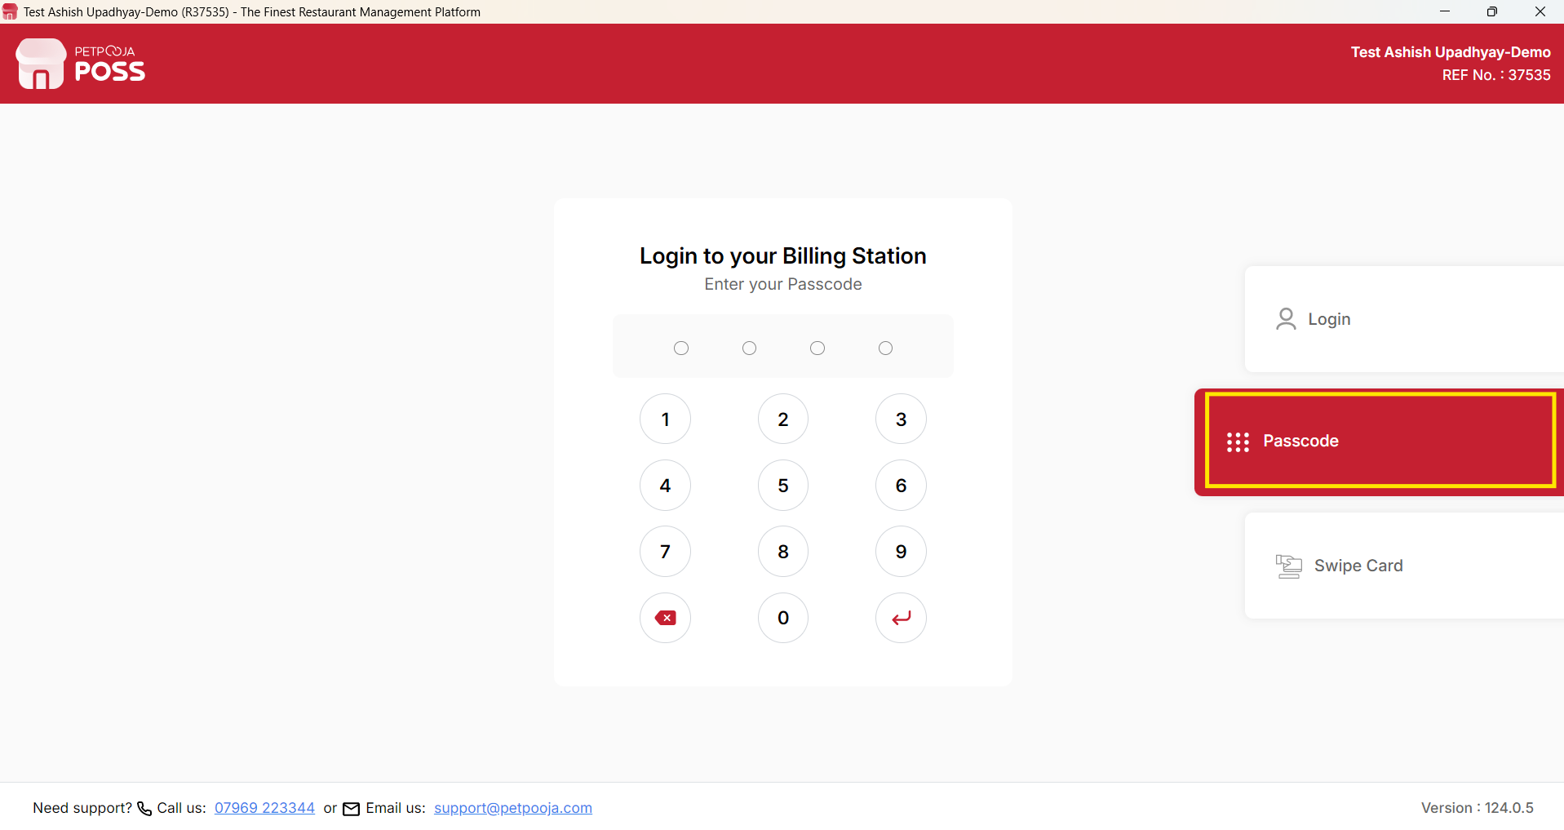
{ Image Name: POS Login Screen Via Passcode ,
Description: The highlighted section indicates the POS Login screen, where users can log in using their assigned Passcode. This is Step 1 to login using Passcode }

1.3. Login Using Swipe Card
Overview:The Swipe Card is a method of login in a POS System in a very quick way using card swipe.Swipe Card login will work only if the outlet has an integrated and configured card reader.

Path: Open POS>>Login >>Passcode
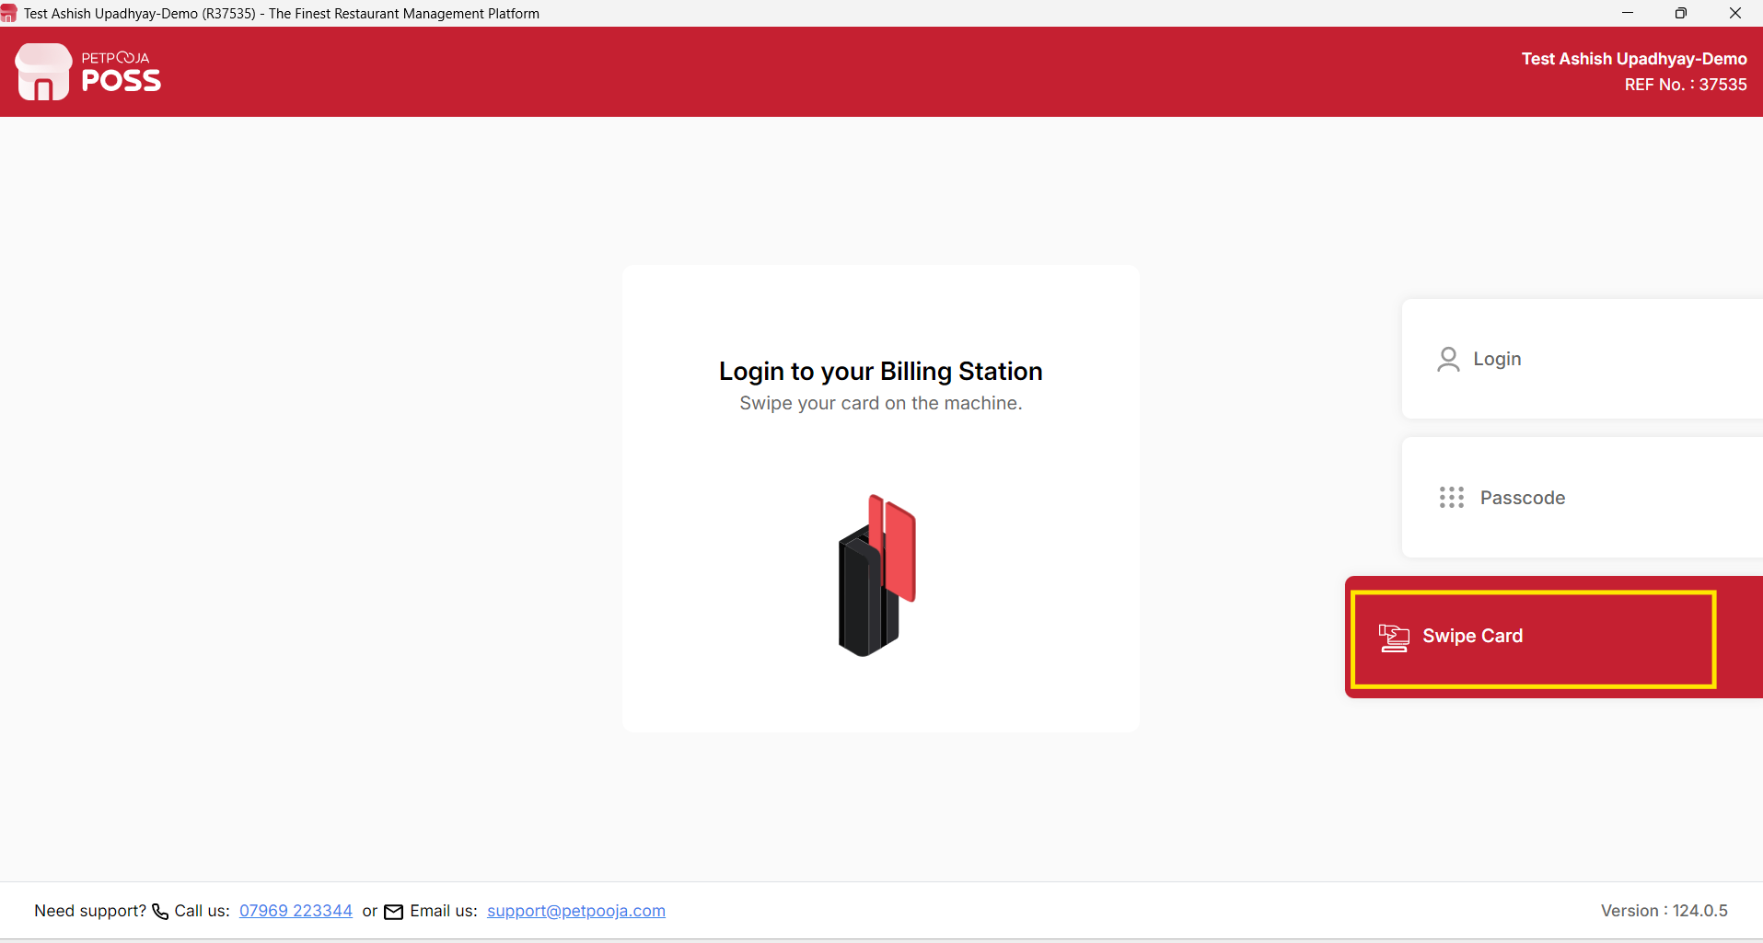
{ Image Name: POS Login Screen Via Swipe Card ,
Description: The highlighted section indicates the POS Login screen, where users can log in using swipe card This is Step 1 to login using Swipe card }
Most Common Cases

- If the customer forgets the POS username & password: most of the time the username and password are both biller (all lowercase, spelled B-I-L-L-E-R)
- If the POS asks for a passcode: the default passcode is 1 2 3 4
- If, after entering the details, the system shows that the account is inactive, check the user's credentials in the User Management section of the dashboard. If the account is inactive, activate the user from the dashboard.
- If the username and passcode are shown as invalid, check them in the User Management section of the dashboard.

2. Dashboard Login Process
Overview: This module contain login process for the Dashboard users with step by step There are three methods to log in to the Dashboard using valid credentials:
URL : https://billing.petpooja.com/
Users can log in to the Dashboard using any of the following three methods:
- Email Address & Password
- Mobile Number & OTP (One-Time Password)
- Sign in with Google

2.1. Login Using Email Address & Password

Overview: The Email & Password Login method is the standard and most secure way to access the Petpooja Dashboard. Users can log in by entering their registered email address and password. Once the credentials are verified successfully, the system redirects the user to the Dashboard homepage, where they can manage restaurant operations, settings, reports, menus, and other administrative functions.

Step 1 : Open petpooja dashboard using URL: billing.petpooja.com
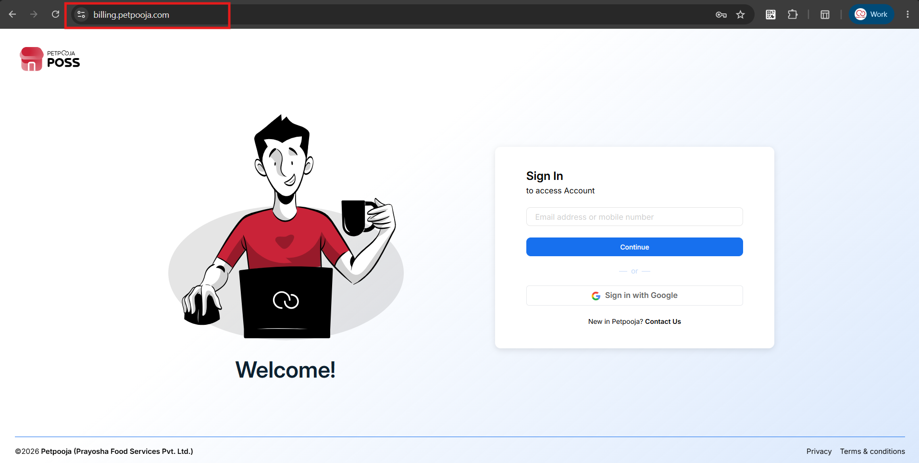
{ Image Name: Petpooja billing dashboard image using Id & Password,
Description:The highlighted section indicates the URL of the Petpooja Billing Dashboard login page. This is the step-1 in the Username & Password login process. Open the URL in your web browser to access the login page, where you can enter your registered username and password to sign in. }

2.2: Login Using Mobile Number & OTP
Overview : The Mobile Number & OTP login method provides a quick and secure way to access the Petpooja Dashboard without entering a username or password. Users simply need to enter their registered mobile number, receive a One-Time Password (OTP) on that number, and verify it to log in. Once the OTP is successfully verified, the user is automatically redirected to the Dashboard homepage.
This login method is ideal for users who want a faster and more convenient sign-in experience while maintaining account security.
Step 1 : Open petpooja dashboard using URL: billing.petpooja.com


{ Image Name: Petpooja billing dashboard image using OTP,
Description:The highlighted section indicates the URL of the Petpooja Billing Dashboard login page. This image indicate step-1 in the OTP Login process }

Step 2: Enter OTP received on register no and click on Sign In button
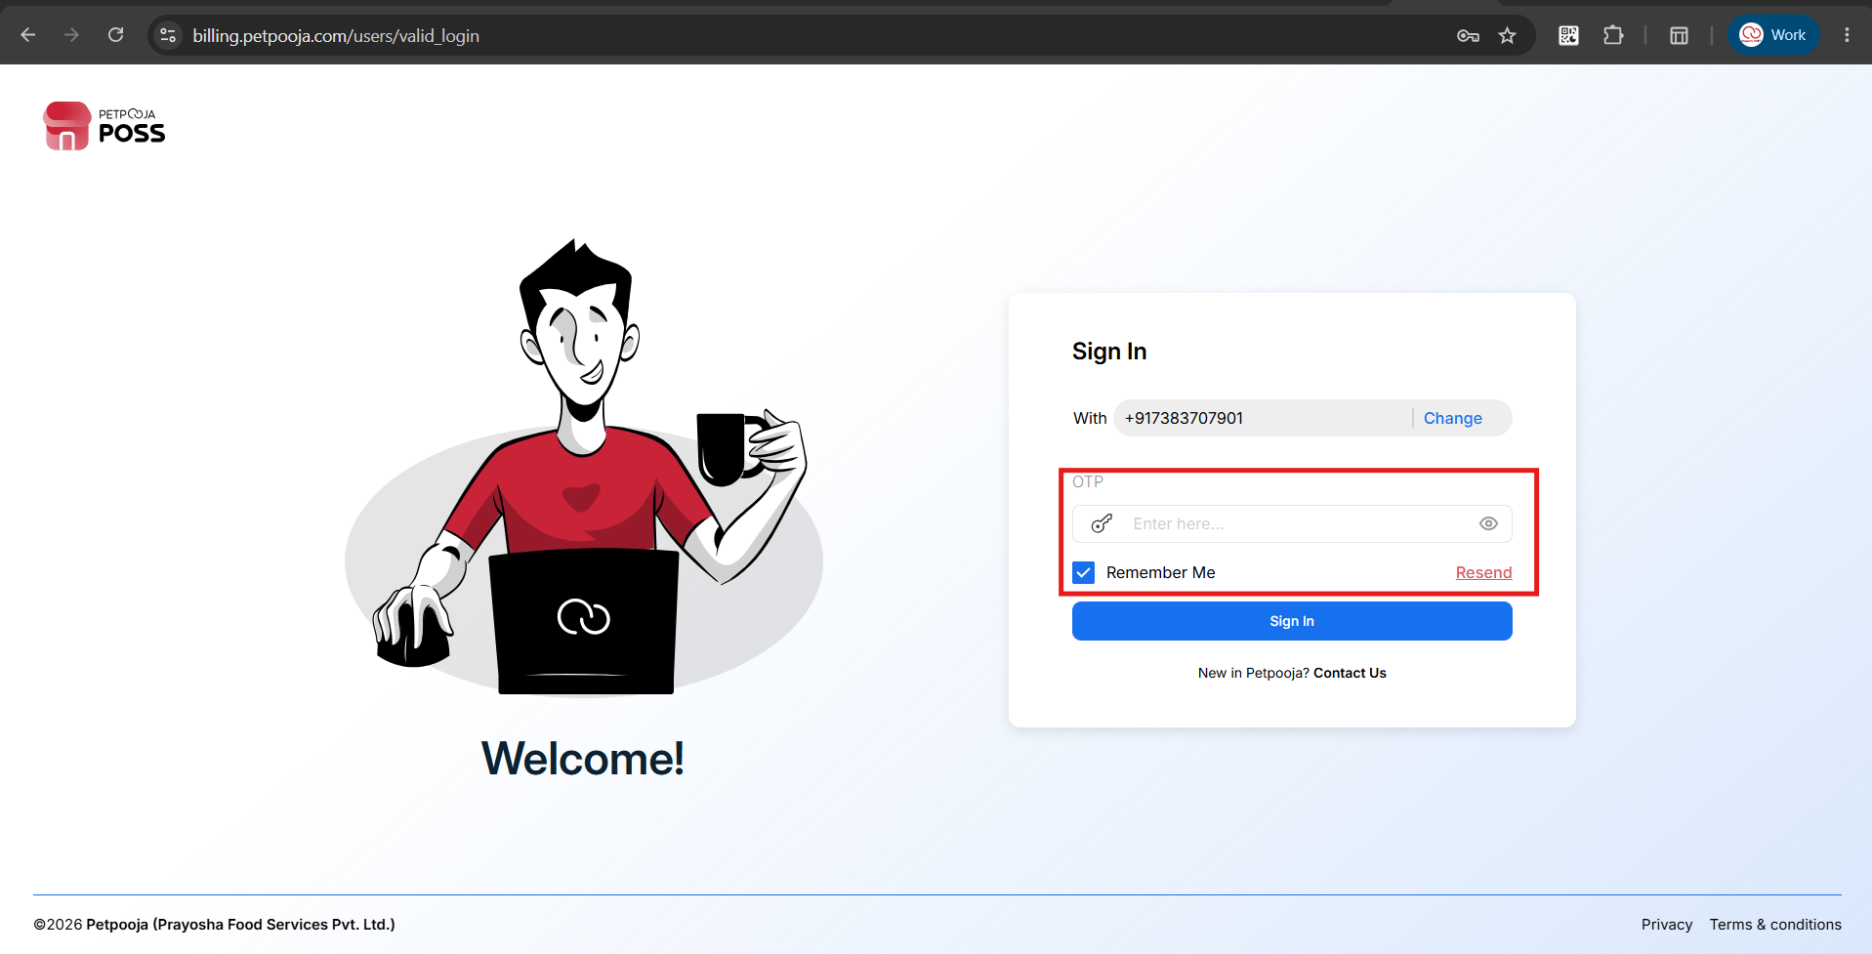
{ Image Name: Dashboard Login process using OTP validation page,
Description:The highlighted section indicates enter OTP to validate to login dashbaord .This image indicate step-2 in the validate OTP to Login process }

2.3: Sign in with Google
Overview : The Sign in with Google option allows users to securely log in to the Petpooja Dashboard using their registered Google account without entering their Dashboard email address and password. This provides a faster and more convenient login experience while leveraging Google's secure authentication process. Once the Google account is successfully verified, users are automatically redirected to the Dashboard homepage.
Step 1 : Open petpooja dashboard using URL: billing.petpooja.com



{ Image Name: Petpooja billing dashboard image using Google email id.,
Description:The highlighted section indicates the URL of the Petpooja Billing Dashboard login page. This image indicates step-1 in the Sign in with google account Login process }

Step 2 : Click on “Sign in with Google” button

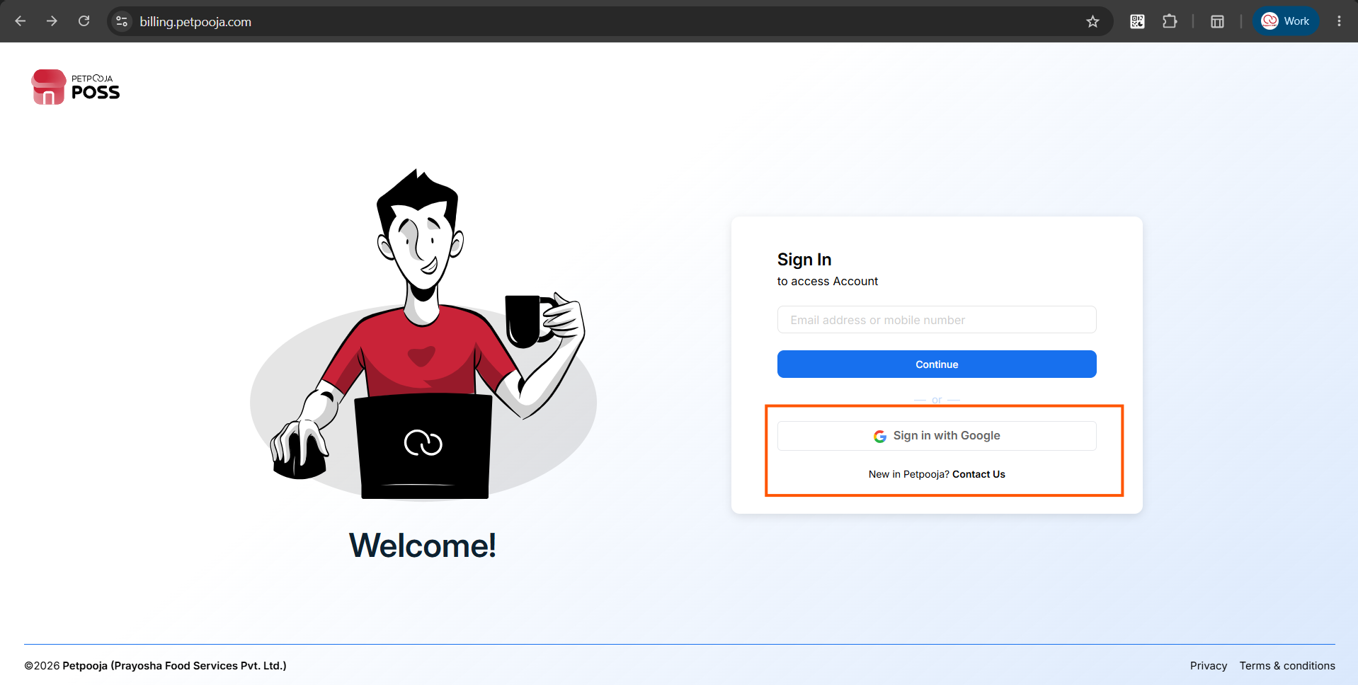
{ Image Name: Petpooja billing dashboard image using Google email id.,
Description:The highlighted section indicates the Sign in with Google button on the Petpooja Billing Dashboard login page. Click this button to log in using your registered Google account. You will be redirected to the Google authentication page, where you can select your Google account and the sign-in process. }

3. Troubleshooting: Dashboard Login Issues
If you encounter issues while trying to access the Petpooja Dashboard, follow the troubleshooting steps below based on your login method.

3.1. General Troubleshooting (Applies to all methods)
- Check the URL: Ensure you are at the correct address: [https://billing.petpooja.com/](https://billing.petpooja.com/)
- Internet Connection: Verify that your device has a stable internet connection.
- Browser Issues: If the page fails to load or buttons are unresponsive, clear your browser's cache and cookies, or try logging in using an "Incognito" or "Private Browsing" window.

3.2. Troubleshooting: Email Address & Password
- "Invalid Credentials" Error:
  - Double-check for typos in your email address.
  - Ensure your keyboard's Caps Lock is turned off.
  - Make sure there are no accidental blank spaces before or after your email/password.
- Forgotten Password: Click on the "Forgot Password" link on the login page. Enter your registered email address to receive a secure password reset link.
- Account Locked/Inactive: If you receive a prompt stating your account is suspended or locked due to too many failed attempts, contact your restaurant administrator or Petpooja Support to unlock it.

3.3. Troubleshooting: Mobile Number & OTP
- Not Receiving the OTP:
  - Wait for 30–60 seconds. Network congestion can sometimes delay SMS delivery.
  - Click the "Resend OTP" button.
  - Check your mobile network signal and ensure your phone is not in Airplane mode.
  - Verify that your mobile provider is not blocking transactional SMS or that a strict DND (Do Not Disturb) filter is not active.
- "Number Not Registered" Error: Ensure you are entering the exact mobile number linked to your Petpooja profile. If you have recently changed your number, you must log in via Email/Password to update it in your profile settings.
- Invalid or Expired OTP: OTPs are time-sensitive. If you wait too long to enter it, the code will expire. Request a new OTP and enter it immediately.

3.4. Troubleshooting: Sign in with Google
- Selecting the Wrong Account: If you successfully sign in with Google but get an "Access Denied" or "Account Not Found" error, you likely selected a personal or alternate Google account. Ensure you are selecting the specific Google Workspace or Gmail account registered with Petpooja.
- Google Prompt Won't Open: If clicking the "Sign in with Google" button does nothing, your browser might be blocking pop-ups. Look for a pop-up blocker icon in your browser's address bar and select "Always allow pop-ups and redirects from billing.petpooja.com".
- Authentication Loop: If the page refreshes repeatedly without logging you in, sign out of all Google accounts in your browser, clear your cookies, and try the process again.

3.5 When to Contact Petpooja Support
Contact Petpooja Technical Support if:
- Password reset email is not received.
- Registered mobile numbers cannot receive OTP.
- Google Sign-In is not linked correctly.
- The account remains locked after waiting.
- Dashboard is inaccessible despite following all troubleshooting steps.
- Login issues continue across multiple browsers and devices.
- Any server-related error persists for an extended period.

